Stacks using Linked Lists

Stack is a linear data structure where insertion and deletion is from top. The insertion is called a push and the deletion is called a pop. Stack follows a last in first out (LIFO) concept.
Stacks can be represented either using arrays or using linked lists. Our topic of discussion is IMPLEMENTATION OF STACKS USING LINKED LISTS.

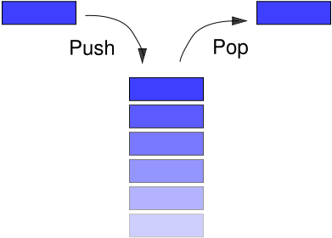

A linked list is a linear data structure having two data types:
- Element or Data (which may be an integer or character etc.)
- Next Pointer(pointing to the next node in the list)
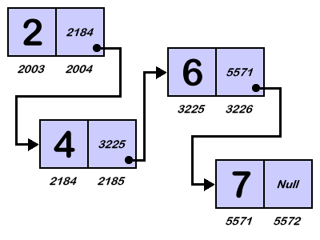
We shall discuss the algorithm and the program for the following operations in stacks using linked list
- Push an element
- Pop an element

- Algorithm to “PUSH” (Insert at Beginning of a linked list)
PUSH_LINKSTACK(ELEMENT,TOP)
1. Start
2. Check if count > MAX then display “STACK OVERFLOW” and EXIT
3. Create a newnode.
4. Make newnode->data = ELEMENT
5. Make newnode->next = TOP
6. Make TOP = newnode
7. Make count = count + 1
8. Exit

- Algorithm to “POP” (Delete at Beginning of a linked list)
POP_LINKSTACK(TOP)
1. Start
2. Check if count < 0 then display “STACK UNDERFLOW” and EXIT
3. Create a tempnode
4. Make tempnode = TOP
5. Make TOP = TOP->NEXT
6. Deallocate the memory for tempnode
7. Make count = count - 1
8. Exit
Program :
#include<stdio.h>
struct node
{
int data;
struct node *next;
};

void push(int);
void pop();

struct node *top;
int MAX = 10,count=0;

void main()
{
int choice;
int element;
top = null;
while(choice != 0)
{
case 1:
scanf(“%d”,&element);
push(element);
break;
case 2:
pop();
break;
}

}
void push(int element)
{
struct node *newnode = (struct node*)malloc(sizeof(struct node));
if(count > MAX)
{
printf(“Stack Overflow\n”);
return;
}
count++;
newnode->data = element;
newnode->next = top;
top = newnode;
return;
}

void pop()
{
struct node *tempnode;
tempnode = (struct node*)malloc(sizeof(struct node));
if(count < 0)
{
printf(“Stack Underflow\n”);
return;
}
count--;
tempnode = top;
top = top->next;
free(tempnode);
return;
}

Queues using Linked List

Queue is a linear data structure where insertion is at the end and deletion is from beginning. The insertion is called an enqueue and the deletion is called a dequeue. Queue follows the first in first out (FIFO) concept.
Queue can be represented either using arrays or using linked lists. Our topic of discussion is IMPLEMENTATION OF QUEUES USING LINKED LISTS.

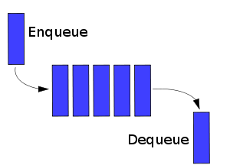

We shall discuss the algorithm and the program for the following operations in queues using linked list
- Enqueue an element
- Dequeue an element
- Algorithm to “ENQUEUE” (Insert at End of a linked list)
ENQUEUE_LINKQUEUE(ELEMENT,REAR)
1. Start
2. Check if rear > MAX then display “QUEUE FULL” and EXIT
3. Create a newnode.
4. Make newnode->data = ELEMENT
5. Make newnode->next = NULL
6. Make REAR->next = newnode
7. REAR = newnode
8. Make rear = rear + 1
9. Exit

- Algorithm to “DEQUEUE” (Delete at Beginning of a linked list)
DEQUEUE_LINKQUEUE(FRONT)
1. Start
2. Check if front = rear then display “QUEUE EMPTY” and EXIT
3. Create a tempnode
4. Make tempnode = FRONT
5. FRONT = FRONT->NEXT
6. Deallocate the memory for tempnode
7. Make front = front + 1
8. Exit

Program :
#include<stdio.h>
struct node
{
int data;
struct node *next;
};

void enqueue(int);
void dequeue();

struct node *front;
struct node *rear;
int MAX = 10,front=0,rear=0;

void main()
{
int choice;
int element;
front = 0;
rear = 0;
while(choice != 0)
{
case 1:
scanf(“%d”,&element);
enqueue(element);
break;
case 2:
dequeue();
break;
}

}
void enqueue(int element)
{
struct node *newnode = (struct node*)malloc(sizeof(struct node));
if(rear > MAX)
{
printf(“Queue Full\n”);
return;
}
rear++;
newnode->data = element;
newnode->next = 0;
rear->next = newnode;
rear = newnode;
return;
}

void dequeue()
{
struct node *tempnode;
tempnode = (struct node*)malloc(sizeof(struct node));
if(front == rear)
{
printf(“Queue Empty\n”);
return;
}
front++;
tempnode = front;
front = front->next;
free(tempnode);
return;
}

